**Class Attendance Mobile App**

Use Case Specification

Submitted to:

Asst. Prof. Ma. Rowena C. Solamo

Faculty Member

Department of Computer Science

College of Engineering

University of the Philippines, Diliman

Submitted by:

Atienza,​ ​John​ Oliver

Austria,​ ​Ronnel​​ Roi

Gabriel,​ ​Kristianne​ Arielle

In partial fulfillment of academic requirements

for the course

CS 191 Software Engineering I

of the

1st Semester, AY 2017-2018

***Unique Reference:***

The documents are stored in the GitHub repository:

<https://github.com/rbaustria/ClassAttendanceMobileApp>

***Document Purpose:***

The document provides the Use Case specification of the software, Class Attendance Mobile App.

***Target Audience:***

The target audience of the document are: the developers of the software, future developers who wish to extend it, and the professor.

***Revision Control***

*History Revision:*

|  |  |  |  |
| --- | --- | --- | --- |
| ***Revision Date*** | ***Person Responsible*** | ***Version***  ***Number*** | ***Modification*** |
| 10/09/11 | Arielle Gabriel | 1.0 | Initial Document |
|  |  |  |  |

*Use-Case Name*: 2.2 Edit a Class

*Description:* This use-case edits an existing class from the list of classes. Editing a class means changing the information about the class and not the students enrolled in the class.

*Preconditions:* Have at least one existing class

*Flow of Events:*

|  |  |
| --- | --- |
| ***Scenario Name*** | ***Description*** |
| Scenario 1 (Basic Flow)  Teacher successfully edits a class | 1. Teacher views the list of classes then selects the class that he/she wants to modify. 2. The teacher edits the information about the said class then tries to save it. 3. The application checks for any error on the entered data. If everything is valid, the class information is updated. |
| Scenario 2  Teacher fails to edit a class | 1. Teacher views the list of classes then selects the class that he/she wants to modify. 2. The teacher edits the information about the said class then tries to save it. 3. The application checks for any error on the entered data. If everything any error is detected, it is displayed by the application and the class information is not updated. |

*Activity Diagram of the Flow of Events:*

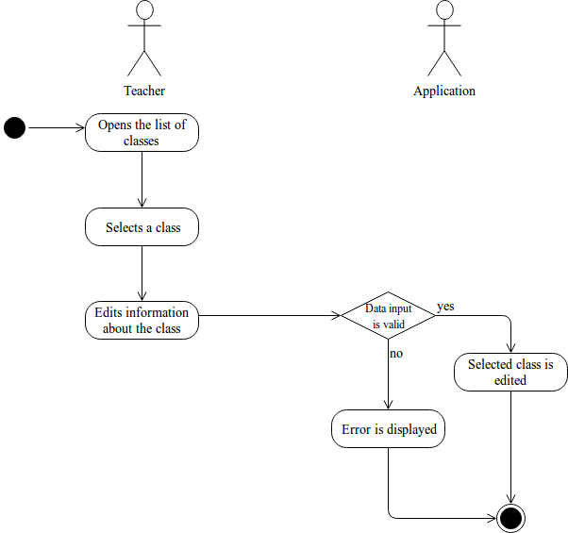

*Postcondition:* Class is edited or class is not edited

*Relationships:* NONE

*Special Requirements:*

NONE